FULL PROJECT REPORT

1. INTRODUCTION AND PROJECT BACKGROUND
Skin cancer detection is a complex healthcare challenge because both patient characteristics and the way skin lesions present clinically can vary considerably. Recognising clinically relevant lesion characteristics can support the early identification of potentially concerning lesions, which is important because early detection can improve patient outcomes. However, lesion presentation represents only one dimension of the available clinical picture. Patient demographics, clinical history, lifestyle habits and environmental characteristics may provide additional context when examining patterns associated with different lesion diagnoses.
The data available for this project was divided across two related tables. The first contained patient-level information, including demographics, clinical history, lifestyle habits and environmental characteristics, while the second contained lesion-level information, including diagnoses, anatomical locations and clinical features. Analysing either dataset independently provides only a partial view of the available information: the patient dataset does not describe how lesions present, while the lesion dataset does not independently provide the wider patient characteristics associated with those lesions. Linking the two tables through their common patient_id therefore provides a more comprehensive analytical view in which patient and lesion characteristics can be examined together.
This project uses an exploratory SQL-based approach to investigate patterns across lesion diagnoses within the linked data. The analysis progresses from independently profiling patient and lesion characteristics to examining how these characteristics vary across individual diagnoses. The six recorded diagnoses are subsequently classified into benign, pre-cancerous and malignant categories, allowing the analysis to investigate whether broader patterns in clinical presentation, anatomical location, demographics and patient characteristics distinguish these groups.
The purpose of this analysis is not to establish causal relationships, determine clinical risk or develop a diagnostic or predictive model. Rather, it seeks to identify and describe patterns within the available data that may provide a foundation for more focused subsequent investigation.

2. PROJECT OBJECTIVE
To explore linked patient and lesion characteristics, identify patterns across lesion diagnoses, and examine characteristics that distinguish malignant, pre-cancerous and benign lesions.

3. DATASET OVERVIEW
The dataset used for this project was provided as a de-identified professional case study dataset under the company pseudonym “Derm AI Diagnostics”. The underlying case was derived from a real-world skin lesion analytics project, with identifying client information withheld.
The source dataset provided for the analysis has two tables: table1 contains patient-level information and table2 contains lesion-level information. Each source table contained 1,088 records.

3.1 Patient Table
The patient table contains demographic information, clinical history, lifestyle habits and environmental characteristics. These variables provide the patient-level context used to investigate how characteristics such as age, gender, clinical history and environmental factors vary across lesion diagnoses.

3.2 Lesion Table
The lesion table contains lesion diagnoses, anatomical locations, clinical features, lesion measurements, biopsy status and associated image identifiers. The table uses a composite primary key consisting of patient_id and lesion_id.

3.3 Dataset Linkage
The two source tables share the common patient_id field, which was used to link the cleaned patient and lesion data. This created a unified analytical view containing both patient and lesion information and enabled characteristics from the two source tables to be examined together.
The resulting analytical dataset contained 1,088 linked records.

3.4 Lesion Diagnoses and Classification
Six lesion diagnoses were represented in the data: ACK, BCC, MEL, NEV, SCC, and SEK.
For the later stage of the analysis, these individual diagnoses were classified into three broader categories: benign, pre-cancerous and malignant. This classification enabled patterns initially examined across individual diagnoses to be reconsidered at a broader diagnostic category level.
The full diagnostic names, category mappings, source variable definitions and derived analytical objects are documented separately in the Data Dictionary.

4. DATA QUALITY ASSESSMENT
A data quality assessment was conducted before any cleaning or analytical transformations were applied. The assessment examined the structure and integrity of the two source tables, completeness and uniqueness, categorical and Boolean values, and the distribution and validity of numerical variables. The purpose was to identify issues that could be corrected confidently, as well as those requiring documentation because their intended meaning could not be established from the available information.

4.1 Structural Assessment
The source dataset consisted of two tables containing 1,088 records each. table1 contained one row per patient, while table2 contained one corresponding lesion record per patient.
Structural checks established that:
- patient_id uniquely identified records in the patient table.
- lesion_id was not globally unique within the lesion table: 81 lesion identifiers are reused across multiple records. However, these repeated lesion identifiers are associated with different patients.
- The combination of patient_id and lesion_id uniquely identified records in the lesion table, confirming the composite primary key structure.
- Every patient record had a corresponding lesion record.
- No orphan lesion records or unmatched patient records were identified.
These checks confirmed complete linkage between the patient and lesion tables and established the identifier integrity required for subsequent integration through patient_id.
The patient table contained demographic, clinical history, lifestyle and environmental variables, while the lesion table contained diagnostic, anatomical, clinical feature, measurement, biopsy and image reference variables. Detailed definitions, data types and coding for individual fields are provided in the Data Dictionary.

4.2 Data Completeness
No major missing value issues were identified among the variables profiled.

4.3 Identifier Variable Assessment
The principal identifier fields, patient_id and lesion_id, were assessed for their structural role rather than treated as analytical variables. img_id was similarly treated primarily as an identifier/reference field and contained no null values.
The identifier assessment supported the integrity of the source structure and confirmed that the patient and lesion tables could be linked completely through patient_id.

4.4 Categorical Variable Assessment
Categorical variables were assessed by examining their recorded values and consistency.
gender contained two categories, MALE and FEMALE, with no missing values. The parental background variables, however, contained inconsistent representations. background_father included both BRASIL and BRAZIL, as well as UNK and UNKNOWN. background_mother similarly contained both UNK and UNKNOWN.
The lesion table contained 14 recorded anatomical regions where lesions occurred and six diagnostic codes (ACK, BCC, MEL, NEV, SCC and SEK).

4.5 Boolean Variable Assessment
Patient-level Boolean variables were complete and contained valid true/false values across lifestyle, environmental and clinical history characteristics. Lesion-level Boolean variables were also complete and contained valid true/false values for biopsy status and recorded clinical features.

4.6 Numerical Variable Assessment
Patient age contained no missing values and ranged from 6 to 94 years, with a mean age of 58.57 years and a median of 60 years.
The lesion measurement variables presented notable data quality concern. Both diameter_1 and diameter_2 contained no null values; however, 581 records (53.40%) were recorded as 0 mm for each variable. Consequently, both variables had a median of 0 mm, despite maximum recorded measurements of 70 mm for diameter_1 and 60 mm for diameter_2.
The fitspatrick variable contained recorded values ranging from 0 to 6. The supplied data definition specifies the Fitzpatrick skin type scale as ranging from 1 to 6, meaning that the 579 observations recorded as 0 fell outside the documented valid range.
Further assessment showed that every record with fitspatrick = 0 also had diameter_1 = 0 and diameter_2 = 0. The systematic co-occurrence of these values across multiple variables suggested a structured data quality issue rather than isolated data entry errors. However, the available documentation did not establish what these zero values represented.

4.7 Data Quality Findings
Overall, the source tables were structurally complete, with complete linkage between patient and lesion records and no major missing value problems among the variables assessed.
Two principal data quality issues were identified:
a) Categorical inconsistencies were present in the parental background variables, including alternative representations of Brazil and unknown backgrounds.
b) Unexplained zero values affected the use of the Fitzpatrick skin type and lesion diameter variables in subsequent analysis. Values of 0 in fitspatrick fell outside the standard and documented valid scale, while the meaning of the zero diameter measurements could not be established from the supplied documentation.
The categorical inconsistencies represented issues that could be standardised confidently during data preparation. In contrast, altering or reclassifying the unexplained zero values would require assumptions unsupported by the available documentation. They were therefore retained in their original form rather than arbitrarily corrected, transformed or manipulated.
The assessment consequently established which transformations could be undertaken with sufficient confidence and which issues should remain explicitly documented. These findings informed the cleaning and transformation decisions described in the following section.

5. METHODOLOGY
The project followed a structured exploratory analytical workflow using PostgreSQL. The analysis progressed from assessment of the raw source data through cleaning and transformation, independent profiling of the patient and lesion tables, integration of the two tables, diagnosis-level analysis and broader lesion category comparisons.
The methodology was designed to preserve the integrity of the source data, ensure that transformations were supported by evidence, and maintain a reproducible analytical workflow. As the project was exploratory and descriptive, the analysis focused on identifying patterns within the supplied dataset rather than establishing causal relationships, statistical associations or predictive models.

5.1 Analytical Approach
A staged analytical approach was used to progressively develop understanding of the data.
The workflow consisted of:
- assessing the structure and quality of the raw source data;
- applying defensible cleaning and standardisation;
- creating cleaned patient and lesion tables;
- profiling patient and lesion characteristics independently;
- linking the cleaned tables through patient_id;
- examining how patient and lesion characteristics varied across the six individual diagnoses;
- classifying the diagnoses into benign, pre-cancerous and malignant categories; and
- comparing characteristics across the broader lesion categories, with particular focus on differences between malignant and benign lesions.
This progression allowed the underlying patient and lesion populations to be understood before relationships between the two were explored.

5.2 Data Quality Assessment
Data quality was assessed before cleaning or analytical transformation.
Structural checks were performed to establish record counts, identifier integrity, uniqueness and the relationship between the two source tables. Variables were then profiled according to their analytical type.
Categorical variables were assessed using distinct values and category distributions to identify inconsistent representations. Boolean variables were assessed for completeness and valid true/false coding. Numerical variables were examined using descriptive measures and value distributions to identify missing, unexpected or potentially invalid observations.
Particular attention was given to observations that fell outside documented definitions or showed unusual distributions. Where the available documentation was insufficient to determine whether an observation represented an error, no corrective assumption was made.
The detailed results of these assessments are presented in Section 5: Data Quality Assessment.

5.3 Data Cleaning and Transformation
Cleaning decisions were restricted to issues for which a defensible correction could be established from the data and supplied definitions.
Cleaned versions of both source tables were created so that the original raw data remained unchanged. Within the patient table, equivalent parental background labels were standardised:
- BRASIL was standardised to BRAZIL in background_father
- UNK was standardised to UNKNOWN in both background_father and background_mother.
No transformations were applied to the lesion variables. In particular, the unexplained zero values in fitspatrick, diameter_1 and diameter_2 were retained in their original form because the available documentation did not provide sufficient evidence to determine their intended meaning.
This approach distinguished correctable inconsistencies from unresolved data quality issues, avoiding arbitrary correction, transformation or manipulation of ambiguous source values.
Post-transformation checks were used to confirm that the cleaned tables retained the source records and variables and that the intended categorical standardisations had been applied.

5.4 Data Integration
Following data preparation, the cleaned patient and lesion tables were linked through their common patient_id field using an inner join.
The resulting unified_skin_lesion_data view combined patient demographics, clinical history, lifestyle and environmental characteristics with lesion diagnosis, anatomical location, clinical features, measurements, biopsy status and image identifiers.
The view was validated by inspecting sample records, checking its total row count and examining distinct patient and lesion identifiers.
Creating a reusable view allowed linked analyses to be conducted without repeatedly reconstructing the join and preserved the cleaned patient and lesion tables as separate analytical objects.

5.5 Exploratory Analytical Strategy
Exploratory analysis was conducted in three stages.
First, the patient table was analysed independently to describe age, gender, parental background, clinical history, lifestyle habits and environmental or household characteristics.
Second, the lesion table was analysed independently to describe diagnosis distribution, anatomical location, recorded clinical features, lesion measurements and biopsy status.
Third, the unified analytical view was used to examine how patient and lesion characteristics varied across the six individual lesion diagnoses: ACK, BCC, MEL, NEV, SCC and SEK.
This staged approach established the overall distributions of patient and lesion characteristics before evaluating differences across diagnostic groups. It also provided appropriate context for interpreting diagnosis-level percentages against the composition of the overall dataset.

5.6 Lesion Classification and Category-Level Analysis
To support higher-level comparison, a second reusable analytical view, classified_skin_lesion_data, was created from the unified analytical view.
A CASE expression derived a diagnosis_category field, grouping the six diagnoses into:
- Benign: NEV, SEK
- Pre-cancerous: ACK
- Malignant: BCC, SCC, MEL
The supplied project brief provided abbreviated diagnostic codes but did not provide their expanded clinical terminology or broader lesion classifications. The full diagnostic names and category mappings were therefore established using authoritative sources, including the NHS, American Academy of Dermatology and National Cancer Institute (see Appendix for references). These sources were used collectively to verify the clinical terminology and status of the six lesion types and support their grouping into benign, pre-cancerous and malignant categories. The original diagnostic codes remained unchanged in the data; the classification was introduced only as a derived analytical field to support category-level comparison.
The resulting view was validated by comparing each original diagnostic code with its assigned category and lesion count to confirm that the classification logic had been applied as intended.
classified_skin_lesion_data was then used to compare clinical features, anatomical locations, patient demographics, clinical history, lifestyle habits and environmental characteristics across the three lesion categories. A final synthesis focused specifically on characteristics that differed between malignant and benign lesions.

5.7 Analytical Measures and SQL Techniques
The analysis primarily used descriptive measures appropriate to the type of variable and analytical question.
Numerical summaries included minimum, maximum, range, mean and median. Categorical analyses used frequencies and proportions. Boolean characteristics were evaluated by calculating the number and percentage of records for which each characteristic was recorded as true.
Percentage calculations were designed around the denominator appropriate to each analytical question rather than applying a single percentage calculation throughout the analysis. For overall patient or lesion distributions, the denominator was the complete relevant population. When multiple Boolean variables were reshaped for profiling, percentages were calculated separately within each variable so that each characteristic was evaluated against its appropriate denominator.
For diagnosis-level comparisons, percentages were calculated within each individual diagnosis. This allowed questions to be expressed as, for example, “Of patients with BCC lesions, what proportion had a family history of cancer?” rather than calculating BCC patients as a proportion of all patients with that characteristic. The same approach was applied at category level, where the denominator was the total number of records within the corresponding benign, pre-cancerous or malignant group.
For Boolean clinical, historical, lifestyle and environmental characteristics, prevalence was calculated as the number of records in which the characteristic was true divided by the total number of records in the relevant diagnosis or lesion category. This denominator-led approach ensured that percentages directly addressed the analytical question being investigated and supported meaningful comparison between groups of unequal size.
Age was additionally grouped into approximately 15-year intervals to support comparison of patient distributions across age groups.
SQL techniques used throughout the analysis included joins, aggregate functions, CASE expressions, filtered aggregation, window functions, CROSS JOIN LATERAL, reusable views and grouped descriptive calculations.

5.8 Interpretation Approach
The project used an exploratory and descriptive analytical approach.
Observed differences were interpreted as patterns within the supplied dataset rather than evidence of causation, independent risk factors, diagnostic predictors or statistically validated associations. No inferential statistical testing, multivariable adjustment or predictive modelling was performed.
Percentages were interpreted alongside absolute counts, particularly where diagnostic groups differed substantially in size. Additional caution was applied to MEL because only 17 melanoma records were represented in the dataset.
Potentially important differences were therefore treated as areas for further investigation rather than definitive clinical conclusions.

5.9 Reproducibility
Reproducibility was incorporated into the analytical workflow through sequential SQL scripts and reusable database objects.
The workflow maintained separation between the raw source tables, cleaned tables and derived analytical views. Cleaning and transformation steps were implemented programmatically, while the unified and classified views provided reusable analytical structures for subsequent queries.
SQL scripts were organised sequentially from data quality assessment and preparation through exploratory and category-level analysis. Supporting documentation records variable definitions, transformations, analytical decisions, data quality issues and derived objects, enabling the analytical process to be reviewed and reproduced.

6. ANALYSIS
Following data preparation, exploratory analysis was conducted to describe the patient and lesion populations independently before examining relationships between patient characteristics, lesion characteristics and diagnoses. This progression established the underlying composition of the data before moving to linked diagnosis-level analysis.

6.1 Patient Profile
The patient table was initially analysed independently to describe the demographic, clinical history, lifestyle and environmental characteristics of the 1,088 patients represented in the dataset.

6.1.1 Age Profile
Patients ranged from 6 to 94 years, representing an age range of 88 years. The mean age was 58.57 years, while the median age was 60 years.
To examine the distribution in greater detail, patients were grouped into approximately 15-year age intervals. Patients were represented across all age groups, but the population was concentrated among middle-aged and older adults. The largest groups were patients aged 61–75 years (364; 33.46%) and 46–60 years (338; 31.07%), which together accounted for 64.53% of all patients. In contrast, patients younger than 31 years accounted for only 5.23% of the dataset.
Interpretation: The age profile demonstrates that older patients were substantially more represented in the dataset than younger patients. This underlying age distribution is important when interpreting subsequent relationships between age and lesion diagnosis.

6.1.2 Gender Distribution
Male patients comprised 726 (66.73%) of the study population, compared with 362 female patients (33.27%). Male patients therefore represented over twice as many records as female patients.
Interpretation: The patient population was predominantly male. This imbalance should be considered when interpreting subsequent diagnosis-level gender distributions because higher male counts may partly reflect the underlying composition of the dataset rather than differences associated with a particular diagnosis alone.

6.1.3 Parental Background
Parental background was examined separately for paternal and maternal records.
For paternal background, 617 patients (56.71%) had an unknown recorded background. Among the full patient population, the most frequently recorded known backgrounds were Pomeranian (183; 16.82%) and German (156; 14.34%), followed by Italian (75; 6.89%) and Brazilian (41; 3.77%).
A similar pattern was observed for maternal background. 613 patients (56.34%) had an unknown maternal background. The most frequently recorded known backgrounds were Pomeranian (186; 17.10%) and German (161; 14.80%), followed by Italian (75; 6.89%) and Brazilian (34; 3.13%).
Interpretation: More than half of the records contained unknown paternal and maternal background information, substantially limiting interpretation of this characteristic. Among patients for whom a specific background was recorded, Pomeranian and German backgrounds were the most frequently represented.

6.1.4 Lifestyle Characteristics
Smoking and alcohol consumption were examined to describe the lifestyle characteristics recorded for the patient population.
Most patients did not report either characteristic. 62 patients (5.70%) were recorded as smokers, while 138 patients (12.68%) reported alcohol consumption.
Interpretation: Smoking and alcohol consumption were relatively uncommon among patients represented in the dataset. Their relatively low overall prevalence provides important context for subsequent analysis of how these characteristics were distributed across lesion diagnoses.

6.1.5 Environmental and Household Characteristics
The environmental and household characteristics examined were pesticide exposure, access to piped water and access to a sewage system.
Pesticide exposure was reported for 223 patients (20.50%). Access to piped water was recorded for 306 patients (28.13%), while 273 patients (25.09%) had access to a sewage system.
Interpretation: Approximately one in five patients reported pesticide exposure, while fewer than one-third had recorded access to piped water or a sewage system. These characteristics establish the environmental profile of the patient population and provide a basis for subsequently examining how their prevalence varied across lesion diagnoses.

6.1.6 Clinical History
Two clinical history characteristics were examined: family history of cancer and previous skin cancer diagnosis.
A family history of cancer was recorded for 272 patients (25.00%), while 224 patients (20.59%) had a previous history of skin cancer. The majority of patients therefore did not report either clinical history characteristic.
Interpretation: Although most patients had neither recorded characteristic, family history of cancer was present among one-quarter of the patient population and previous skin cancer diagnosis among approximately one-fifth. Their prevalence within the overall population provides an important baseline for subsequent comparison across lesion diagnoses.

6.1.7 Patient Profile Summary
The patient-level analysis showed a population predominantly composed of middle-aged and older adults, with male patients representing approximately two-thirds of records. More than half of the records contained unknown paternal and maternal background information, limiting interpretation of these variables. Smoking and alcohol consumption were relatively uncommon, while pesticide exposure was recorded for approximately one-fifth of patients. One-quarter of patients had a family history of cancer and approximately one-fifth had a previous history of skin cancer. These baseline characteristics provided the context for subsequent analysis of how patient characteristics varied across lesion diagnoses.

6.2 Lesion Profile
The lesion table was initially analysed independently to describe the distribution of diagnoses, anatomical locations, recorded clinical features, lesion measurements and biopsy status. This established the overall lesion profile before these characteristics were subsequently examined in relation to patient characteristics and individual diagnoses.

6.2.1 Distribution of Lesion Diagnoses
Six lesion diagnoses were represented in the dataset. ACK was the most frequently recorded diagnosis, accounting for 461 records (42.37%), followed by BCC with 273 (25.09%). Together, ACK and BCC represented 67.46% of all recorded lesions. Melanoma was the least frequently recorded diagnosis, with 17 records (1.56%).
Interpretation: The diagnostic distribution was uneven, with more than two-thirds of records accounted for by ACK and BCC. This underlying imbalance is important when interpreting subsequent comparisons across individual diagnoses, particularly for diagnoses represented by relatively few records.

6.2.2 Anatomical Distribution
Lesions were recorded across 14 anatomical regions. The face was the most frequently recorded location (278; 25.55%), followed by the forearm (219; 20.13%), chest (124; 11.40%) and back (105; 9.65%). The face and forearm alone accounted for 45.68% of recorded lesions.
Interpretation: The anatomical distribution was concentrated in a relatively small number of regions, with the face and forearm particularly prominent. This overall distribution provides a baseline for later analysis of whether anatomical patterns differed across diagnoses.

6.2.3 Clinical Features
Six recorded clinical features were examined: itching, pain, bleeding, growth, change and elevation.
Itching was the most frequently recorded feature, affecting 670 lesions (61.58%), followed by elevation (611; 56.16%) and growth (510; 46.88%). Bleeding was recorded for 20.40% of lesions, pain for 13.88%, and change for 9.10%.
Interpretation: Itching, elevation and growth were the most prevalent recorded clinical features in the overall lesion population, while bleeding, pain and change were less frequently reported. These overall prevalence levels provide an important reference point for subsequent comparisons of clinical feature profiles across diagnoses.

6.2.4 Lesion Measurements
Both lesion diameter variables were profiled as part of the exploratory assessment. Each contained 581 zero measurements (53.40%). Among the remaining observations, diameter_1 had recorded values up to 70 mm, while diameter_2 had values up to 60 mm.
As established during the data quality assessment, the meaning of the large number of zero measurements could not be verified from the supplied documentation.
Interpretation: The high prevalence of unexplained zero measurements substantially affected the diameter distributions and prevented the variables from being used confidently for subsequent lesion size comparisons. The original values were retained for transparency but were not relied upon in the later diagnosis- and category-level analyses.

6.2.5 Biopsy Status
Of the 1,088 lesions, 458 (42.10%) were recorded as biopsied, while 630 (57.90%) were not biopsied.
Interpretation: The majority of lesions in the dataset were not biopsied.

6.2.6 Lesion Profile Summary
The lesion-level analysis showed an uneven diagnostic distribution dominated by ACK and BCC, with lesions most frequently recorded on the face and forearm. Itching, elevation and growth were the most prevalent clinical features, while fewer than half of lesion records were biopsied. Although lesion diameter measurements were profiled, the high prevalence of unexplained zero values limited their analytical use. These findings established the overall lesion profile and provided the baseline for examining how lesion and patient characteristics varied across individual diagnoses.

6.3 Linked Diagnosis-Level Analysis
Following the independent profiling of patient and lesion characteristics, the unified_skin_lesion_data view was used to examine how these characteristics varied across the six individual lesion diagnoses. Linking the two tables enabled patient demographics, clinical history, lifestyle and environmental characteristics to be considered alongside lesion diagnosis, anatomical location and clinical presentation.
Because the diagnostic groups differed substantially in size, percentages were calculated within each diagnosis to support comparison. Absolute counts were considered alongside percentages, particularly for melanoma (MEL), which contained only 17 records.

6.3.1 Age Distribution Across Diagnoses
Age distributions varied considerably across the six diagnoses. ACK, BCC, SCC and SEK were concentrated among patients in the older age groups, particularly those aged 46–75 years. In contrast, NEV showed a substantially younger profile: 41.67% of patients with NEV lesions were aged 31–45 years and 28.47% were aged 16–30 years.
MEL was most frequently recorded among patients aged 46–60 years. However, only 17 MEL records were present in the dataset.
Interpretation: Individual diagnoses showed distinct age profiles. ACK, BCC, SCC and SEK were predominantly represented among middle-aged and older patients, whereas NEV occurred across a younger patient profile. The MEL distribution should be interpreted cautiously because of its small number of observations.

6.3.2 Gender Distribution Across Diagnoses
Male patients represented the majority of patients with ACK (70.72%), NEV (70.83%) and SEK (79.56%) lesions. BCC and SCC had more balanced gender distributions, although males remained slightly more represented at 55.31% and 55.36%, respectively.
MEL was the only diagnosis for which female patients represented the majority (58.82%), although this percentage was based on only 17 MEL records.
Interpretation: Gender composition differed across diagnoses, with particularly strong male representation among ACK, NEV and SEK. However, these patterns should be considered alongside the overall patient profile, in which males already represented 66.73% of the dataset. The apparent female majority among MEL records also warrants caution because of the small number of MEL observations.
That comparison with the baseline patient profile is analytically important.

6.3.3 Anatomical Distribution Across Diagnoses
Anatomical distributions also varied across diagnoses.
ACK lesions were most frequently recorded on the forearm (168; 36.44%), while BCC and SEK were most frequently recorded on the face, accounting for 89 BCC records (32.60%) and 53 SEK records (38.69%).
NEV lesions were most frequently located on the back (45; 31.25%). SCC was most frequently recorded on the face (11; 19.64%), while MEL was most frequently recorded on the back (4; 23.53%).
Interpretation: The diagnoses displayed different anatomical profiles within the dataset. ACK showed a particularly strong forearm concentration, BCC and SEK were prominently represented on the face, and NEV was most frequently recorded on the back. SCC and MEL were more dispersed across anatomical regions, although their smaller record counts require more cautious interpretation.

6.3.4 Clinical Features Across Diagnoses
Clinical feature profiles differed considerably across diagnoses.
- ACK: Itching was the predominant recorded feature, affecting 350 patients (75.92%), while the other clinical features were substantially less common.
- BCC: Multiple features were common, particularly elevation (236; 86.45%), itching (212; 77.66%), growth (206; 75.46%) and bleeding (163; 59.71%).
- MEL: Growth (16; 94.12%) and change (14; 82.35%) were particularly prominent, although these percentages were based on only 17 records.
- NEV and SEK: Both were primarily characterised by elevation and growth, while bleeding and pain were uncommon.
- SCC: Elevation (45; 80.36%), itching (43; 76.79%) and growth (37; 66.07%) were common, while pain (19; 33.93%) and bleeding (17; 30.36%) were also recorded in substantial proportions.
Interpretation: No single clinical feature characterised all diagnoses. Instead, the diagnoses displayed different combinations of recorded features. BCC and SCC exhibited several features at relatively high prevalence, ACK was particularly characterised by itching, and NEV and SEK showed profiles dominated by elevation and growth with relatively little bleeding or pain. MEL showed a distinctive combination of growth and change, but the small number of records limits the strength of this observation.
This provides early descriptive evidence for one of the project's eventual synthesis points: combinations of characteristics appear more informative than isolated features. It should not, however, be interpreted as establishing diagnostic predictors.

6.3.5 Biopsy Status Across Diagnoses
Biopsy status showed a pronounced difference across diagnoses. All BCC (273; 100%), MEL (17; 100%) and SCC (56; 100%) records were biopsied. In contrast, only 20.61% of ACK, 8.33% of NEV and 3.65% of SEK records were biopsied.
Interpretation: Biopsy status was strongly differentiated by diagnosis within this dataset. BCC, MEL and SCC were universally recorded as biopsied, whereas the large majority of ACK, NEV and SEK records were not.

6.3.6 Clinical History Across Diagnoses
A family history of cancer was most prevalent among patients with SCC (31; 55.36%), BCC (147; 53.85%) and MEL (9; 52.94%) lesions.
Previous skin cancer diagnosis was similarly more prevalent among patients with BCC (128; 46.89%), SCC (23; 41.07%) and MEL (6; 35.29%) than among those with ACK, NEV and SEK lesions.
Interpretation: Patients with BCC and SCC showed substantially greater prevalence of both family history of cancer and previous skin cancer diagnosis than patients with ACK, NEV and SEK. MEL displayed a similar proportional pattern, although its percentages were based on only 17 records.
These differences describe clinical history profiles within the dataset and do not establish that either characteristic causes or predicts a particular lesion diagnosis.

6.3.7 Lifestyle Characteristics Across Diagnoses
Alcohol consumption was more prevalent among patients with MEL (5; 29.41%), SCC (16; 28.57%) and BCC (77; 28.21%) lesions than among patients with ACK, NEV and SEK lesions. Although MEL had the highest percentage, this represented only 5 of 17 records, while BCC contained the largest absolute number of patients who reported drinking.
Smoking was most prevalent proportionally among patients with SCC lesions (15; 26.79%). Lower proportions were observed among MEL (2; 11.76%) and BCC (30; 10.99%), while smoking was uncommon among patients with ACK, NEV and SEK lesions.
Interpretation: Lifestyle profiles varied across diagnoses, with smoking and alcohol consumption generally more prevalent among BCC and SCC than ACK, NEV and SEK. MEL also showed relatively high percentages for these characteristics, but the small absolute numbers require caution.
These are descriptive differences only and do not demonstrate that smoking or alcohol consumption is associated with, predicts or causes a particular lesion diagnosis.

6.3.8 Environmental and Household Characteristics Across Diagnoses
Environmental and household characteristics showed substantial variation across diagnoses.
Pesticide exposure was most prevalent among patients with BCC (127; 46.52%), MEL (7; 41.18%) and SCC (22; 39.29%) lesions. In contrast, pesticide exposure was uncommon among patients with NEV (3; 2.08%) and SEK (2; 1.46%) lesions.
Access to piped water was most prevalent among patients with SCC (36; 64.29%), BCC (150; 54.95%) and MEL (9; 52.94%) lesions. A similar pattern was observed for access to a sewage system, with higher proportions among SCC (35; 62.50%), MEL (9; 52.94%) and BCC (127; 46.52%).
Interpretation: BCC and SCC consistently showed higher prevalence of pesticide exposure and the recorded household infrastructure characteristics than ACK, NEV and SEK. MEL showed similarly high percentages for several characteristics, although these estimates were based on a small number of observations.
These differences should not be interpreted as evidence that pesticide exposure, piped water or sewage system access influences lesion diagnosis. The analysis is descriptive, and other characteristics that differ between diagnostic groups may contribute to the observed patterns.

6.3.9 Linked Analysis Summary
The linked analysis identified substantial variation across individual diagnoses in age, gender, anatomical location, clinical presentation, biopsy status, clinical history, lifestyle habits and environmental characteristics. ACK, BCC, SCC and SEK generally showed older age profiles, whereas NEV was represented among younger patients. Anatomical and clinical feature profiles also differed, with ACK particularly concentrated on the forearm and characterised by itching, BCC and SCC displaying multiple commonly recorded clinical features, and NEV and SEK showing different patterns dominated by elevation and growth.
Patient-level characteristics provided additional differentiation. Family history of cancer and previous skin cancer diagnosis were more prevalent among BCC and SCC, while lifestyle and environmental characteristics also varied across diagnoses. MEL displayed several distinctive proportional patterns, but its small number of observations (n = 17) limits the strength of those comparisons.
Overall, the linked analysis demonstrated the analytical value of combining the patient and lesion tables: several of the observed relationships could not have been examined using either table independently. The findings also indicated that diagnoses were characterised by combinations of demographic, anatomical, clinical and patient-level characteristics rather than a single distinguishing feature. These patterns remained descriptive and provided the basis for the subsequent grouping of diagnoses into benign, pre-cancerous and malignant categories.

6.4 Lesion Category Analysis
Following the diagnosis-level exploratory analysis, the six recorded lesion diagnoses were grouped into broader clinical categories to support comparison of benign, pre-cancerous and malignant lesions. This stage addressed the central analytical objective of identifying characteristics that distinguish the broader lesion groups.

6.4.1 Creation and Validation of the Lesion Classification
A new analytical view, classified_skin_lesion_data, was created from the unified analytical view. A derived field, diagnosis_category, grouped the six diagnoses as follows:
- Benign: NEV and SEK
- Pre-cancerous: ACK
- Malignant: BCC, SCC and MEL
The classification was applied once within the view so that subsequent analyses could use the broader diagnostic groups without repeatedly applying the same CASE expression.
Validation confirmed that all six diagnostic codes were successfully assigned to one of the three intended categories.
The original diagnostic codes were retained alongside the new classification, allowing both diagnosis-level and category-level analysis to remain available.

6.4.2 Distribution of Lesion Categories
Pre-cancerous lesions formed the largest category, accounting for 461 records (42.37%). Malignant lesions accounted for 346 (31.80%), while benign lesions represented 281 (25.83%).
Interpretation: All three categories were substantially represented in the dataset, although the distribution was uneven. Nearly one-third of records were classified as malignant, providing sufficient representation for descriptive comparison with benign and pre-cancerous lesions.

6.4.3 Clinical Features Across Lesion Categories
Clinical feature profiles differed substantially across the three lesion categories.
Malignant lesions displayed the broadest combination of frequently recorded features. Elevation was present in 286 lesions (82.66%), itching in 260 (75.14%), and growth in 259 (74.86%). Bleeding (180; 52.02%) and pain (128; 36.99%) were also relatively common.
Benign lesions were primarily characterised by elevation (203; 72.24%) and growth (174; 61.92%). In contrast, bleeding (4; 1.42%) and pain (5; 1.78%) were rarely recorded.
Pre-cancerous lesions were predominantly characterised by itching (350; 75.92%), followed by elevation (122; 26.46%) and growth (77; 16.70%). Bleeding (38; 8.24%), pain (18; 3.90%) and change (17; 3.69%) were less frequently recorded.
Interpretation: The three lesion categories exhibited distinct clinical feature profiles. Bleeding and pain showed particularly pronounced descriptive differences between malignant and benign lesions, while elevation and growth were common in both categories and therefore showed less separation. Pre-cancerous lesions were especially characterised by itching.
Overall, the results suggest that combinations of clinical features provide a more informative descriptive profile of lesion categories than any single feature considered independently.

6.4.4 Anatomical Distribution Across Lesion Categories
The face was the most frequently recorded anatomical location for both malignant (102; 29.48%) and benign (79; 28.11%) lesions. Among pre-cancerous lesions, the forearm was the most common site (168; 36.44%), followed by the face (97; 21.04%).
Benign lesions were also frequently located on the back (59; 21.00%) and chest (37; 13.17%). Malignant lesions were commonly recorded on the chest (52; 15.03%) and nose (47; 13.58%) after the face.
Pre-cancerous lesions showed a stronger concentration on the forearm, followed by the face, arm (52; 11.28%) and hand (45; 9.76%).
Interpretation: Anatomical distribution varied across the three categories, although the face remained a prominent site across all groups. Pre-cancerous lesions showed the most pronounced concentration in a single anatomical region, with more than one-third recorded on the forearm. Benign and malignant lesions displayed more dispersed distributions beyond their shared prominence on the face.

6.4.5 Patient Demographics Across Lesion Categories
Age and gender were examined jointly to describe the demographic profiles associated with the three lesion categories.
Benign lesions occurred among patients across all age groups and were the only category represented among patients aged 0–15 years. The largest demographic groups were males aged 61–75 (53; 18.86%), males aged 31–45 (49; 17.44%) and males aged 46–60 (43; 15.30%).
Malignant lesions were concentrated among older patients. The largest demographic groups were males aged 61–75 (71; 20.52%), males aged 46–60 (60; 17.34%) and females aged 46–60 (57; 16.47%). No malignant lesions were recorded among patients aged 0–15.
Pre-cancerous lesions showed an even stronger concentration among older male patients. Males aged 61–75 represented the largest demographic group (132; 28.63%), followed by males aged 46–60 (102; 22.13%).
Interpretation: Patient demographic profiles differed across lesion categories. Benign lesions occurred across a broader age range and showed greater representation among younger patients, although most benign lesions were still recorded among patients aged 31–75. Malignant and pre-cancerous lesions were concentrated predominantly among middle-aged and older patients.
Male patients represented many of the largest age-gender groups, particularly within the pre-cancerous category. However, this pattern should be interpreted in the context of the overall patient population, in which males already represented 66.73% of records.
Overall, age provided a clearer descriptive distinction between lesion categories than gender alone.

6.4.6 Clinical History Across Lesion Categories
Two patient clinical history characteristics were examined: family history of cancer and previous skin cancer diagnosis.
Among patients with malignant lesions, 187 (54.05%) had a family history of cancer. This compared with 67 (14.53%) patients with pre-cancerous lesions and 18 (6.41%) patients with benign lesions.
Previous skin cancer diagnosis showed a similar pattern. It was recorded among 157 patients (45.38%) with malignant lesions, compared with 54 (11.71%) with pre-cancerous lesions and 13 (4.63%) with benign lesions.
Interpretation: Clinical history showed one of the clearest descriptive differences across the lesion categories. Family history of cancer and previous skin cancer diagnosis were substantially more prevalent among patients with malignant lesions than among those with benign or pre-cancerous lesions.
Patients with pre-cancerous lesions consistently occupied an intermediate position between the malignant and benign groups.
These differences describe patterns within the dataset and do not establish that either clinical history characteristic causes or predicts malignancy.

6.4.7 Lifestyle Characteristics Across Lesion Categories
Alcohol consumption was reported by 98 patients (28.32%) with malignant lesions, compared with 33 (7.16%) patients with pre-cancerous lesions and 7 (2.49%) patients with benign lesions.
Smoking followed a similar pattern. It was reported by 47 patients (13.58%) with malignant lesions, compared with 13 (2.82%) with pre-cancerous lesions and 2 (0.71%) with benign lesions.
Interpretation: Smoking and alcohol consumption were more prevalent among patients with malignant lesions than among those with pre-cancerous or benign lesions. The difference was particularly pronounced for alcohol consumption.
These findings represent descriptive relationships within the dataset and do not demonstrate that either lifestyle characteristic causes malignant lesions or constitutes an independent risk factor.

6.4.8 Environmental and Household Characteristics Across Lesion Categories
Environmental and household characteristics also differed substantially across lesion categories.
Among patients with malignant lesions, 195 (56.36%) had access to piped water, compared with 90 (19.52%) patients with pre-cancerous lesions and 21 (7.47%) patients with benign lesions.
Access to a sewage system was recorded among 171 patients (49.42%) with malignant lesions, compared with 83 (18.00%) with pre-cancerous lesions and 19 (6.76%) with benign lesions.
Pesticide exposure was reported by 156 patients (45.09%) with malignant lesions, compared with 62 (13.45%) with pre-cancerous lesions and only 5 (1.78%) with benign lesions.
Interpretation: Patients with malignant lesions showed the highest prevalence of all three recorded environmental and household characteristics, while patients with pre-cancerous lesions generally occupied an intermediate position and those with benign lesions showed the lowest prevalence.
The difference was particularly pronounced for pesticide exposure. However, the observed patterns should not be interpreted as evidence that pesticide exposure, piped water or sewage system access causes or independently predicts lesion malignancy. Other demographic, geographic, socioeconomic or sampling characteristics not evaluated in this exploratory analysis may contribute to these differences.

6.4.9 Characteristics Distinguishing Malignant and Benign Lesions
The category-level analysis identified several descriptive characteristics that differed substantially between malignant and benign lesions.

Clinical Features
Malignant lesions showed substantially greater prevalence of:
- Bleeding: 52.02% vs. 1.42%
- Pain: 36.99% vs. 1.78%
- Itching: 75.14% vs. 21.35%
- Change: 18.21% vs. 6.76%
Elevation (82.66% vs. 72.24%) and growth (74.86% vs. 61.92%) were common in both malignant and benign lesions, producing less pronounced differences.

Anatomical Location
The face was the most common site for both malignant (29.48%) and benign (28.11%) lesions. Beyond the face, malignant lesions were frequently recorded on the chest (15.03%) and nose (13.58%), while benign lesions showed greater representation on the back (21.00%) and chest (13.17%).

Patient Demographics
Malignant lesions were strongly concentrated among middle-aged and older patients, with very little representation among patients aged 30 years or younger. Benign lesions occurred across all age groups and showed greater representation among younger patients, although most benign lesions remained concentrated among patients aged 31–75.

Clinical History
Among patients with malignant lesions:
- 54.05% had a family history of cancer, compared with 6.41% among patients with benign lesions.
- 45.38% had a previous skin cancer diagnosis, compared with 4.63% among patients with benign lesions.
These represented some of the largest differences observed in patient characteristics.

Lifestyle Characteristics
Alcohol consumption was reported among 28.32% of patients with malignant lesions compared with 2.49% of those with benign lesions. Smoking was reported among 13.58% of patients with malignant lesions compared with 0.71% of those with benign lesions.

Environmental and Household Characteristics
Patients with malignant lesions showed substantially higher prevalence of:
- Pesticide exposure: 45.09% vs. 1.78%
- Piped water access: 56.36% vs. 7.47%
- Sewage system access: 49.42% vs. 6.76%

7. FINDINGS
The analysis identified six principal findings from the linked patient and lesion data.

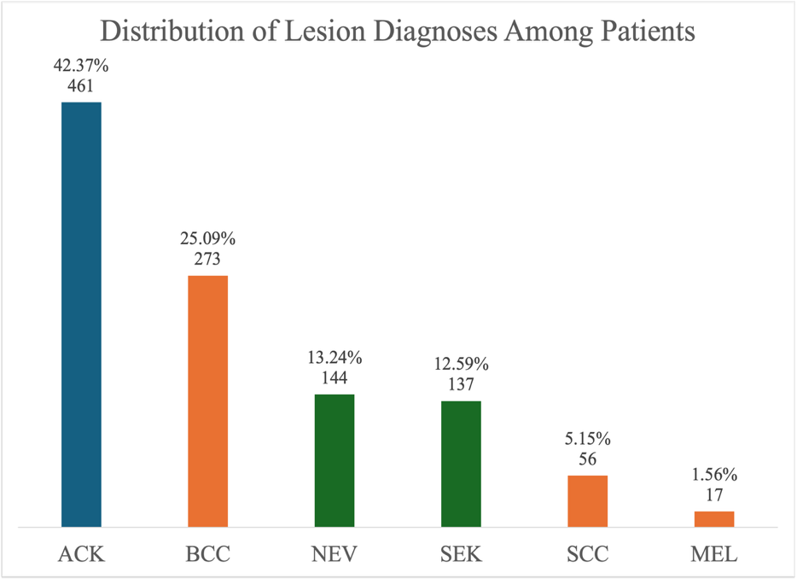
7.1 Diagnosis and Lesion Category Composition
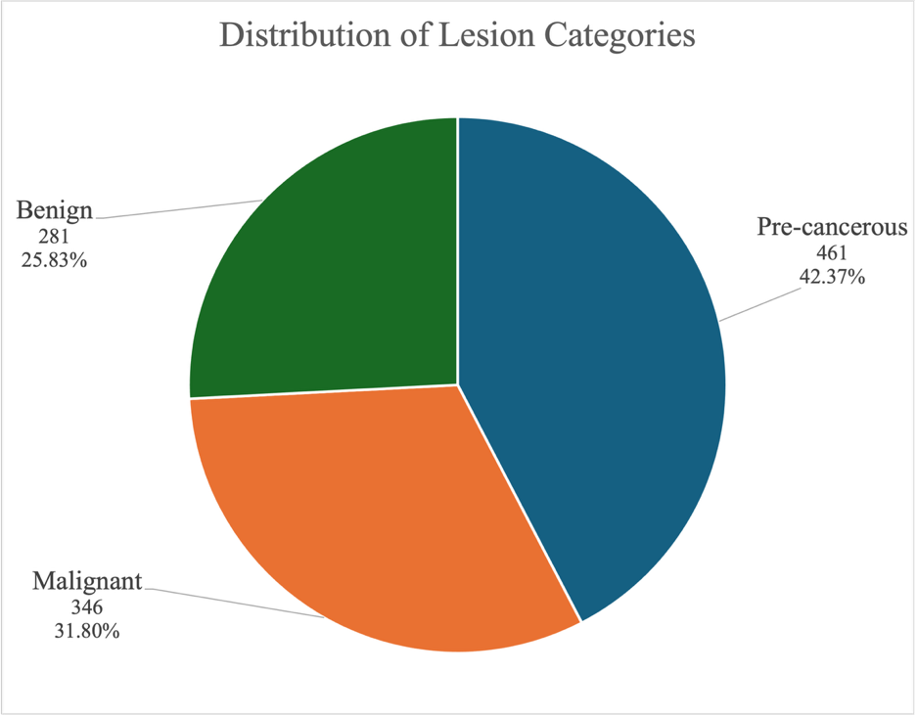
Pre-cancerous lesions were the most common lesion category, accounting for 461 (42.37%) of the 1,088 linked records. All pre-cancerous cases were ACK (actinic keratosis), making ACK the most frequently recorded individual diagnosis in the dataset. Malignant lesions accounted for 346 (31.80%) records, while benign lesions accounted for 281 (25.83%).

7.2 Clinical Features by Lesion Category
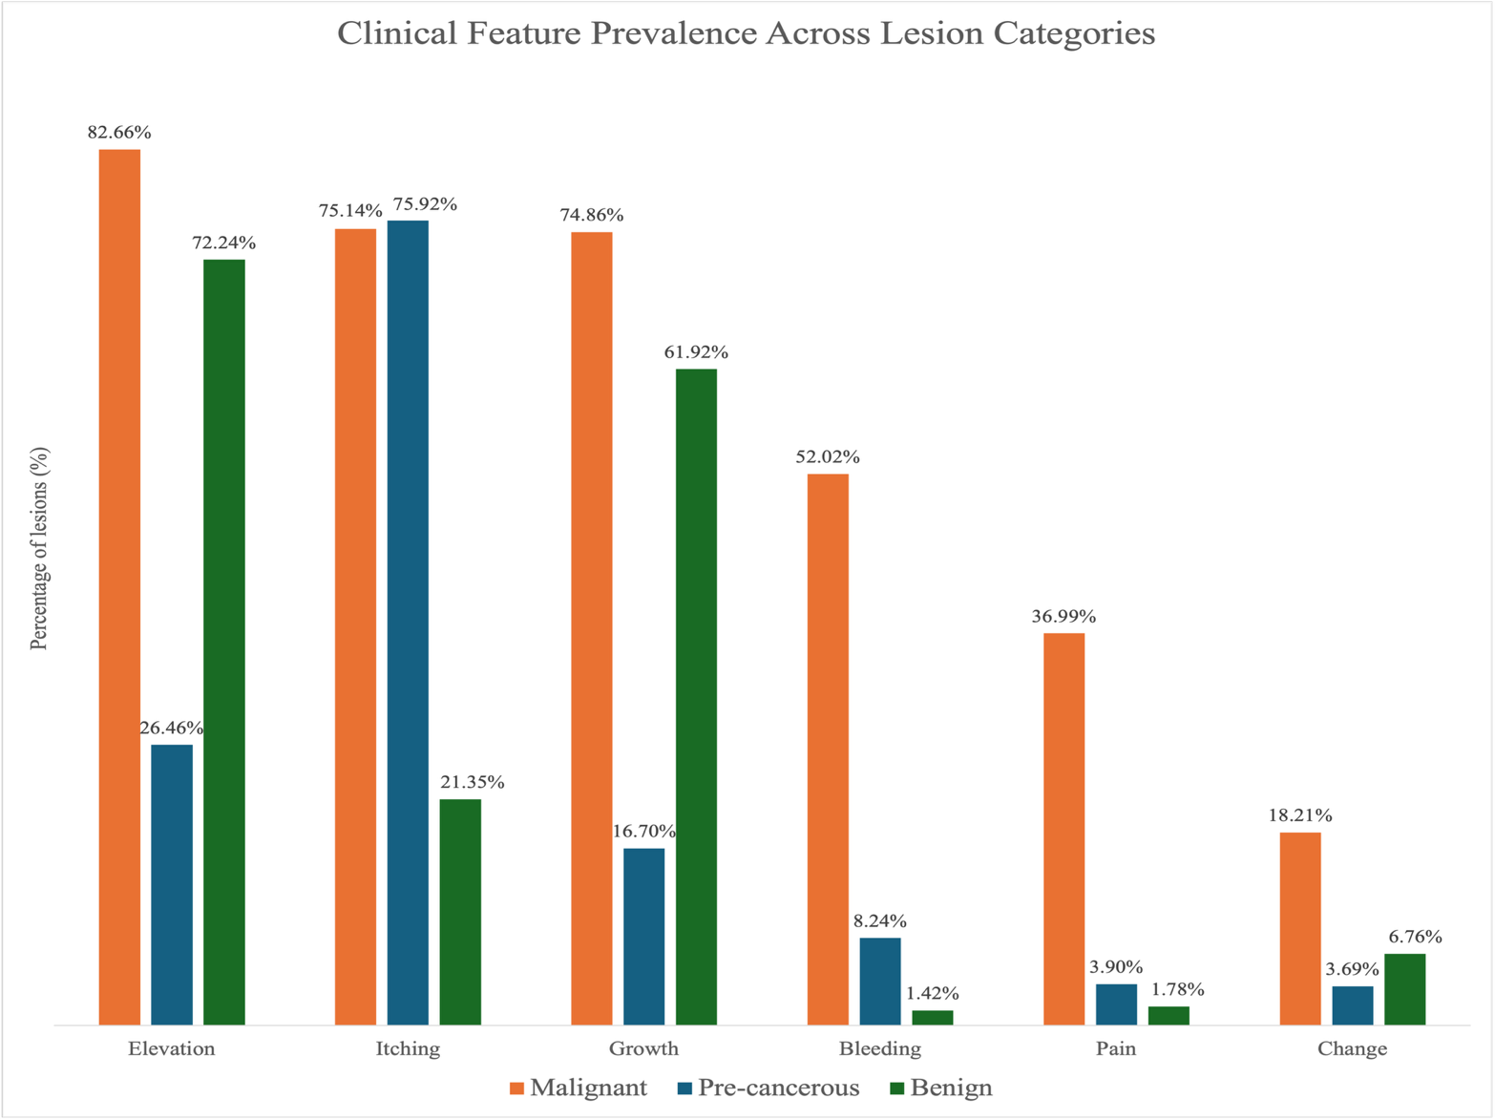
Malignant lesions showed the broadest clinical feature profile. Elevation (82.66%), itching (75.14%) and growth (74.86%) were common, while bleeding (52.02%) and pain (36.99%) were substantially more prevalent among malignant lesions than benign lesions (1.42% and 1.78%, respectively). Pre-cancerous lesions were predominantly characterised by itching (75.92%), followed by elevation (26.46%) and growth (16.70%).
7.3 Anatomical Distribution
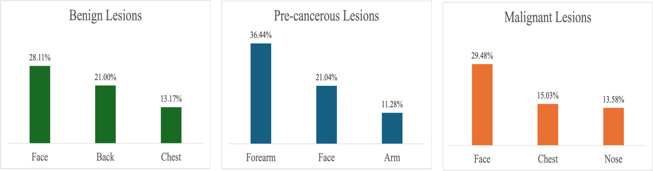
The face was a prominent lesion site across all three categories, ranking first among malignant (29.48%) and benign lesions (28.11%) and second among pre-cancerous lesions (21.04%). Pre-cancerous lesions showed a different anatomical pattern, occurring most frequently on the forearm (36.44%), while the back was the second most common site for benign lesions (21.00%) and the chest for malignant lesions (15.03%).

7.4 Demographic Patterns
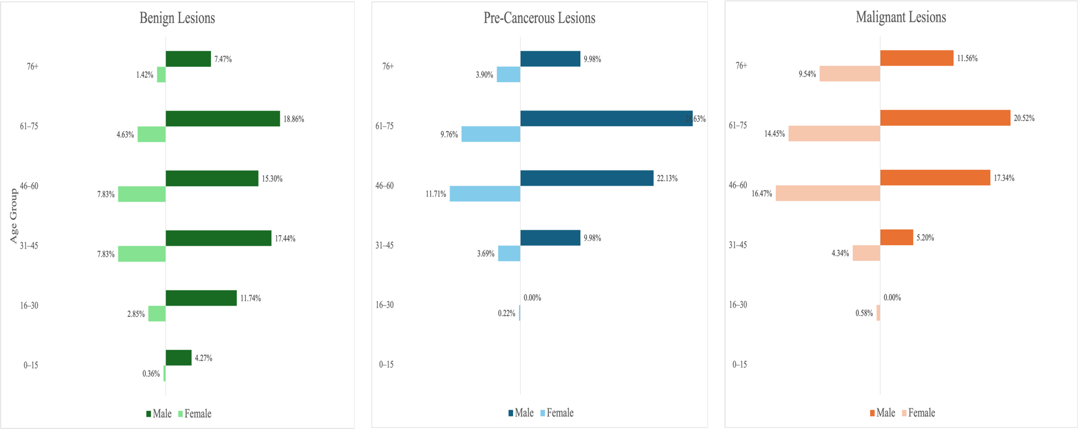
Malignant and pre-cancerous lesions were concentrated among older patients. Patients aged 46 years and above accounted for 89.88% of malignant and 86.11% of pre-cancerous lesion records. In contrast, benign lesions were distributed more broadly across every age group, including younger age groups. The combined age and gender analysis also showed substantial male representation across the major age groups, particularly among pre-cancerous lesions.
7.5 Clinical History
Clinical history showed a pronounced difference across lesion categories. Among patients with malignant lesions, 54.05% had a family history of cancer and 45.38% had a previous skin cancer diagnosis. These characteristics were considerably less prevalent among patients with pre-cancerous lesions (14.53% and 11.71%, respectively) and benign lesions (6.41% and 4.63%, respectively).
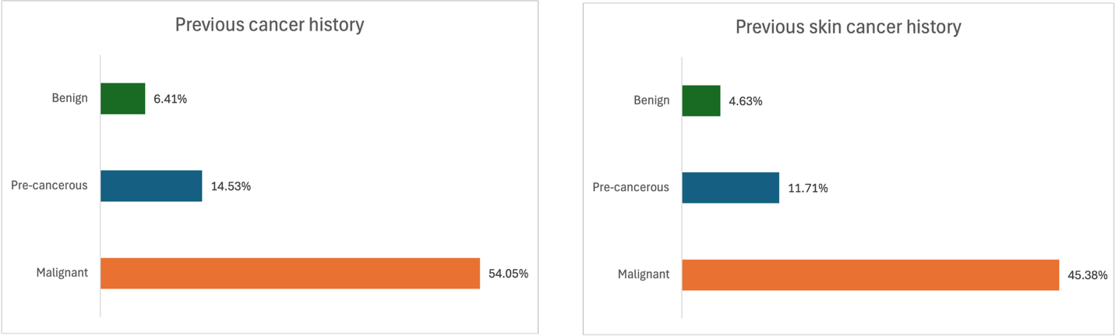

7.6 Overall Synthesis
The lesion categories were not characterised by a single distinguishing factor, but by combinations of clinical, demographic and patient history characteristics. Malignant lesions showed the broadest clinical feature profile, with particularly pronounced differences in bleeding and pain compared with benign lesions and were concentrated among older patients. Family history of cancer and previous skin cancer diagnosis were also substantially more prevalent among patients with malignant lesions.
Pre-cancerous lesions were strongly characterised by itching, older age and a concentration on the forearm, while benign lesions showed a broader age distribution and comparatively low prevalence of bleeding, pain and cancer history characteristics.
These patterns are descriptive associations within the analysed dataset and identify areas for more focused investigation. They do not establish clinical predictors or causal relationships.

8. DISCUSSION
The analysis aimed to explore linked patient and lesion characteristics, identify patterns across lesion diagnoses, and examine characteristics that distinguish malignant, pre-cancerous and benign lesions. The findings demonstrate the value of analysing patient and lesion information together: differences between lesion groups were observed not only in clinical presentation and anatomical location, but also in patient age and clinical history.
A central finding was that no single characteristic clearly distinguished the lesion categories. Instead, the categories displayed different combinations of characteristics. This is particularly apparent when malignant and benign lesions are compared. Clinical features such as bleeding and pain showed pronounced differences, while elevation and growth were common in both groups. Patient age and clinical history provided further differentiation, suggesting that the most informative patterns in this dataset emerge when lesion presentation is considered alongside patient characteristics.

8.1 Clinical Presentation and Lesion Category
Clinical features provided some of the clearest descriptive differences between lesion categories. Malignant lesions displayed a broader clinical-feature profile, with elevation, itching and growth frequently recorded alongside substantially greater prevalence of bleeding and pain than among benign lesions.
However, several features were not exclusive to malignant lesions. Elevation and growth, for example, were common among both malignant and benign lesions. Itching was also highly prevalent among pre-cancerous lesions and therefore did not uniquely characterise malignancy.
This distinction is important. Although individual clinical features varied across categories, the results do not support treating any single recorded feature as a standalone indicator of lesion category. Instead, the analysis suggests that patterns of co-occurring clinical characteristics may warrant greater attention than isolated features.
The MEL findings provide an additional example. Growth and change were highly prevalent among MEL lesions, but only 17 MEL records were available. The proportional pattern is notable within the dataset but cannot support strong conclusions without a larger number of observations.

8.2 Patient Age as an Important Descriptive Characteristic
Age emerged as one of the clearer demographic differences across lesion groups. Malignant and pre-cancerous lesions were strongly concentrated among patients aged 46 years and above, whereas benign lesions were distributed more broadly across the age range.
This pattern remained visible despite the overall dataset already being weighted towards middle-aged and older patients. It therefore contributes useful context to the differences observed between lesion categories.
Gender provided less clear differentiation. Although males represented many of the largest demographic groups, the overall patient population was already predominantly male. Consequently, diagnosis- or category-level male predominance cannot be interpreted independently of the underlying gender composition of the dataset.
This illustrates the importance of considering group-level findings against the baseline characteristics of the study population, rather than interpreting percentages in isolation.

8.3 Clinical History Provided Strong Patient-Level Differentiation
Family history of cancer and previous skin cancer diagnosis showed some of the most pronounced patient-level differences between lesion categories.
Both characteristics were substantially more prevalent among patients with malignant lesions than among those with benign lesions, while the pre-cancerous group occupied an intermediate position.
These patterns make clinical history a particularly relevant area for further investigation. Importantly, however, the analysis does not establish whether these characteristics independently distinguish malignant lesions after accounting for age, diagnosis composition or other patient characteristics.
The findings should therefore be interpreted as evidence of descriptive differentiation within this dataset, rather than evidence that clinical history independently predicts malignancy.

8.4 Anatomical Patterns Provided Additional Context
Anatomical location differed across diagnoses and lesion categories but provided less clear separation between malignant and benign lesions than some clinical and patient-history characteristics.
The face was the most common site for both malignant and benign lesions, demonstrating that a frequently occurring anatomical location does not necessarily distinguish the two categories. More specific patterns appeared at diagnosis level: ACK was concentrated on the forearm, BCC and SEK were most frequently recorded on the face, and NEV was most frequently recorded on the back.
The strong forearm concentration among pre-cancerous lesions was particularly notable and reflected the distribution of ACK, which constituted the entire pre-cancerous category.
This also demonstrates an important consequence of the classification approach: category-level patterns can be strongly influenced by the diagnoses that make up each category. Because ACK alone constitutes the pre-cancerous group, characteristics of that category are necessarily characteristics of ACK within this dataset. Similarly, patterns in the malignant category reflect the combined distributions of BCC, SCC and MEL, with BCC contributing substantially more records than the other two malignant diagnoses.
Category-level findings should therefore be interpreted alongside the underlying diagnosis-level analysis rather than as completely independent observations.

8.5 Lifestyle and Environmental Patterns Require Cautious Interpretation
Lifestyle and environmental characteristics showed substantial differences across lesion categories. Smoking, alcohol consumption and pesticide exposure were more prevalent among patients with malignant lesions than among those with benign lesions. Large differences were also observed for piped water and sewage-system access.
These results are analytically interesting but more difficult to interpret than the differences observed in clinical features or clinical history.
The analysis did not account for potential relationships between these variables and other characteristics such as age, geographic location, socioeconomic circumstances or other unmeasured factors. For example, differences in household infrastructure cannot reasonably be interpreted as having a direct relationship with lesion malignancy solely from the observed percentages.
These variables therefore represent exploratory signals rather than substantive conclusions and would require more focused investigation using additional contextual information and appropriate statistical methods.

8.6 Value of Linking Patient and Lesion Data
One of the most important analytical outcomes of the project was methodological: several of the identified patterns could not have been examined using either source table independently.
The lesion table provided diagnosis, anatomical location and clinical presentation, while the patient table provided demographic, clinical-history, lifestyle and environmental context. Linking the two through patient_id allowed questions such as whether clinical history, age or environmental characteristics differed across lesion diagnoses and categories to be investigated.
The linked analysis therefore produced a more complete analytical picture than independent profiling alone. It demonstrates the value of relational data integration when clinically relevant information is distributed across different parts of a data model.

8.7 Overall Interpretation
Taken together, the findings suggest that the lesion categories in this dataset are best understood through multidimensional profiles rather than isolated characteristics.
Clinical presentation provided important differentiation, particularly through bleeding and pain, while patient age and clinical history added further distinction between malignant and benign lesion groups. Anatomical location contributed additional context, whereas lifestyle and environmental characteristics generated potentially interesting patterns requiring more cautious investigation.
The analysis therefore achieved its exploratory objective by identifying characteristics and combinations of characteristics that vary across lesion diagnoses and broader clinical categories. It also narrowed the areas that may warrant deeper investigation: particularly clinical-feature combinations, age profiles and clinical history.
These findings should not be interpreted as diagnostic rules, independent risk factors or evidence of causation. Establishing whether the identified characteristics are statistically associated with lesion category, independently predictive of malignancy or clinically generalisable would require further analysis beyond the descriptive scope of this project.

9. LIMITATIONS
The findings of this project should be considered within several limitations relating to data quality, dataset composition and the exploratory nature of the analysis.

9.1 Unresolved Fitzpatrick Skin Type and Lesion Diameter Values
The principal data quality limitation concerned fitspatrick, diameter_1 and diameter_2. The documented Fitzpatrick scale ranged from 1 to 6, yet 579 records contained a value of 0, while both lesion-diameter variables contained 581 zero measurements (53.40%).
All records with fitspatrick = 0 also contained zero values for both diameter measurements. Although this systematic pattern indicated an underlying coding or data quality issue, the meaning of the zeros could not be established from the available documentation.
The values therefore remained untouched rather than arbitrarily corrected, transformed or manipulated. Consequently, Fitzpatrick skin type was excluded from subsequent analysis, while lesion-diameter measurements could not be meaningfully incorporated into diagnosis- or category-level comparisons.

9.2 Unequal Diagnostic Group Sizes
The six diagnoses were unevenly represented. ACK and BCC accounted for a substantial proportion of the dataset, while MEL contained only 17 records.
Percentages from smaller diagnostic groups can appear substantial while representing very few observations. MEL findings were therefore interpreted cautiously and alongside absolute counts. The unequal distribution also means that larger diagnoses exert greater influence on aggregated lesion-category patterns.

9.3 Composition of the Broader Lesion Categories
The broader lesion categories differed in their composition. The pre-cancerous category consisted exclusively of ACK, while the benign category combined NEV and SEK and the malignant category combined BCC, SCC and MEL.
Consequently, pre-cancerous category patterns directly reflect ACK within this dataset, while benign and malignant category patterns are influenced by the relative representation of their constituent diagnoses. Category-level findings should therefore be considered alongside the underlying diagnosis-level analysis.

9.4 Characteristics of the Patient Population
The patient population was predominantly male (66.73%) and concentrated among middle-aged and older patients, with 64.53% aged 46–75 years.
These underlying characteristics affect interpretation of demographic patterns observed across diagnoses and lesion categories. The findings describe the supplied study population and should not be assumed to represent the demographic distribution of skin lesions in a broader population.
In addition, more than half of paternal (56.71%) and maternal (56.34%) background records were unknown, substantially limiting meaningful analysis of parental background.

9.5 Descriptive Analytical Design
The project was designed as an exploratory SQL analysis and used descriptive comparisons rather than inferential statistical testing, multivariable adjustment or predictive modelling.
The observed differences therefore identify patterns within the dataset but do not establish statistical significance, independent associations, causation or predictive relationships.
This is particularly important where multiple patient characteristics may be related. For example, differences observed in lifestyle or environmental characteristics could partly reflect differences in age or other characteristics between lesion groups. The analysis did not adjust for these potential relationships.

9.6 Generalisability
The findings are specific to the 1,088 linked records contained in the supplied dataset. The analysis did not establish that these records constitute a random or population-representative sample, and the findings were not evaluated using an external dataset.
The results should therefore be interpreted as patterns within the analysed dataset rather than assumed to generalise to other populations, geographic settings or healthcare contexts.

10. RECOMMENDATIONS
Based on the findings and limitations of this analysis, future work should focus on strengthening the evidence behind the patterns identified and addressing the data constraints that limited their interpretation.
- Resolve the unresolved measurement and coding issues: The meaning of the zero values recorded for Fitzpatrick skin type and lesion diameter should be clarified from the original data source or supporting documentation. Resolving these issues would allow skin type and lesion size to be incorporated reliably into future analysis.
- Expand and improve diagnostic representation: Future analysis would benefit from a larger and more balanced dataset, particularly for less represented diagnoses such as melanoma. This would provide more stable diagnosis-level comparisons and reduce the influence of disproportionately represented diagnoses on broader lesion-category findings.
- Prioritise the strongest descriptive patterns for further investigation: Clinical-feature combinations, patient age, family history of cancer and previous skin cancer diagnosis emerged as some of the clearest characteristics differentiating lesion groups. These should form the primary focus of subsequent investigation rather than treating all observed characteristics as equally informative.
- Test whether the identified patterns persist under statistical analysis: Further work should move beyond descriptive comparison to assess whether the observed relationships remain meaningful after accounting for other patient and lesion characteristics. This is particularly important for determining whether the patterns identified in this exploratory analysis represent independent associations or reflect differences in the composition of the diagnostic groups.
- Investigate lifestyle and environmental findings with additional context: The differences observed in smoking, alcohol consumption, pesticide exposure and household infrastructure warrant further investigation but should be examined alongside relevant demographic, geographic and socioeconomic information before meaningful conclusions are drawn.
- Build on the linked patient-lesion analytical structure: Future research should continue to analyse patient and lesion information together. The project demonstrated that combining clinical presentation with patient demographics and clinical history provides a more informative view of lesion patterns than examining either source table independently.
Overall, this project establishes a foundation for more focused investigation of skin lesion characteristics. Future work should build on that foundation by improving data quality and representation, validating the strongest identified patterns, and progressing from exploratory description toward appropriately designed statistical and predictive analysis where justified.

APPENDIX
SQL Scripts
The complete SQL workflow supporting this analysis is available in the project repository. The scripts document the analytical process from initial data-quality assessment and cleaning through exploratory analysis and lesion-category analysis.
SQL File | Purpose
01_data_quality_assessment.sql | Assesses source-table structure, identifier integrity, completeness, categorical and Boolean consistency, numerical distributions and potential data-quality issues. Creates the cleaned patient and lesion tables and applies validated categorical standardisation.
02_exploratory_analysis.sql | Profiles patient and lesion characteristics, creates the unified analytical view, and conducts linked diagnosis-level exploratory analysis.
03_lesion_classification_analysis.sql | Creates the classified analytical view and examines patterns across benign, pre-cancerous and malignant lesion categories, including the malignant-versus-benign synthesis.
The scripts are organised sequentially and should be reviewed or executed in numerical order because later stages depend on cleaned tables and analytical views created during earlier stages.

Supporting Documentation
Additional project documentation is available in the repository:
- Data Dictionary: Documents source variable definitions, data types and coding; lesion diagnostic terminology and classification; and derived analytical objects.
- Project Charter: Defines the healthcare problem, project objective, scope, analytical questions, stakeholder context, deliverables, success criteria and project limitations.
- README: Provides a portfolio-level overview of the project, analytical workflow, key findings and skills demonstrated.

Supporting Visualisation Workbook
- skin_lesion_visualisations.xlsx: Contains SQL-derived analytical outputs and supporting tables used to produce the report visualisations.

Clinical References for Lesion Classification
The source project brief provided abbreviated diagnostic codes but did not provide their expanded clinical terminology or broader lesion classifications. The following authoritative clinical sources were used collectively to verify the clinical status of the six lesion types and support their grouping into benign, pre-cancerous and malignant categories.
- American Academy of Dermatology (AAD). Actinic Keratosis: Overview
- American Academy of Dermatology (AAD). Seborrheic Keratoses: Overview
- National Cancer Institute (NCI). Skin Cancer Treatment (PDQ®) – Patient Version
- National Health Service (NHS). What is Non-Melanoma Skin Cancer?
- National Health Service (NHS). What is Melanoma Skin Cancer?
- National Health Service (NHS). Actinic Keratoses (Solar Keratoses)
- Primary Care Dermatology Society (PCDS). Melanocytic naevi – an overview.

